Music proposal – 27 February 2021
Your wedding is an intimate reflection of you and as such requires musical and creative attention. To authentically convey that feeling to the guests sharing in this momentous day, your musical input is invaluable.
Over the next months, we’ll be working with you on your wedding soundtrack. Building on our experience of what works and what doesn’t, we’ll guide you in the repertoire selection process from guest arrivals to closing song.
Most of the suggested acts below are open to learning new repertoire, so if you’ve got something specific in mind, let us know. While we’ll try to our best to accommodate you, we’ll also be honest when we feel something won’t work musically or is not possible.
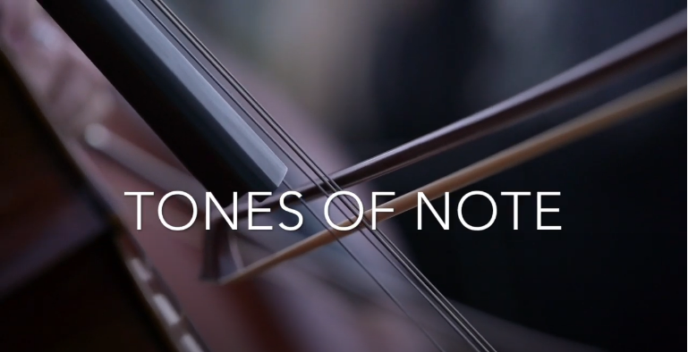

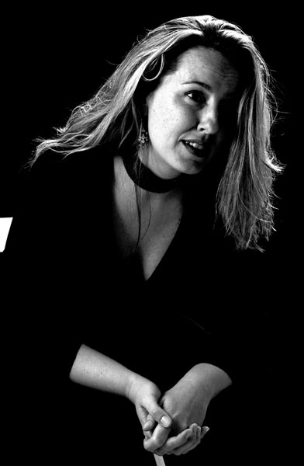
Ceremony: String quintet including double bass to perform with trumpet and organ/keys player to accompany soprano singer Louise Howlett on selected songs during the ceremony.
Louise Howlett was classically trained at the Royal College of Music in London and has been singing professionally for over 10 years, developing her own unique combination of classical, jazz and pop music for themed events such as ‘ A Night at the Oscars’,’ Showstoppers’ and ‘Valentine’s Romance’. Her Cape Town debut took place with the Cape Town Philharmonic Orchestra at their Kirstenbosch Millennium Concert, and over the years she has sung at both large corporate functions and small intimate venues, using her ability to transform her voice in the styles she sings to suit each occasion.
Weddings are her specialty, and Louise’s versatility means that she is able to provide a classical touch to the ceremony and a contemporary feel for the pre-reception drinks – knowing as she does that choosing the right music is as important a decision as choosing the right flowers or dress.

Louise works with pianist Albert Kombrink, as well as a variety of musicians – providing accompaniment ranging from guitar to string ensembles – and would be glad to assist with creating a musical program to ensure that your day is truly memorable.
Louise Howlett - Ave Maria – please excuse the quality of this video, it was recorded on a phone.
Louise Howlett - Somewhere Over the Rainbow
Joining Louise on vocals we have the option of including the Tygerberg Children’s Choir.
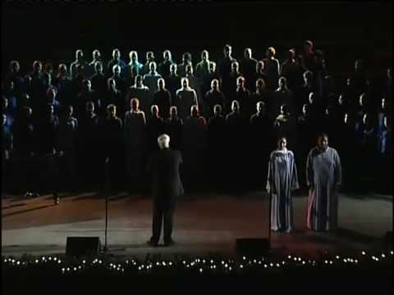
For 47 years the choir, based in Cape Town's Northern Suburbs and under the baton of internationally acclaimed conductor Hendrik D Loock with Theresa Loock as arranger and accompanist, has taken lovers of choral music on a very special musical journey. In May 2019, Mr Loock finally laid down his baton and a new choir leader, Karina Erasmus, was appointed along with a new accompanist, Marelize Koch.
The choir regularly performs with great aplomb for heads of state, princes, kings and queens and is one of South Africa's proudest export products. The choir has won every major international choral competition since its inception in 1972 and its unsurpassed legato singing, maturity of sound, musical power and dynamic interpretation of very difficult material makes Tygerberg Children's Choir a foremost exponent in the world of international competition choirs. The choir has a vast legacy of excellent choral CDs as testimony of its prowess.
In July 2010 year the choir was crowned World Champions and received gold medals in the Folklore and Music of the Religions categories at the 6th World Choir Games in Shaoxing, China. In 2012 the choir came second and won gold in the Children’s Choir division at the 7th World Choir Games in Cincinnati, USA. They also won a further two gold medals – in the Music of the Religions and Folklore divisions.
And again in 2018, the choir did exceptionally well at the 10th World Choir Games in Tshwane, South Africa. They participated in a mammoth four categories and were crowned World Champions in two categories – the highly coveted Children’s Choirs division and the Musica Sacra with Accompaniment division. They achieved 3rd places in two further categories – Pop Choirs and Folklore with Accompaniment. In total they won four gold medals.
Tygerberg Children’s Choir is currently the number one children’s choir in the world and holds the 4th position over all on the Interkultur World Rankings.

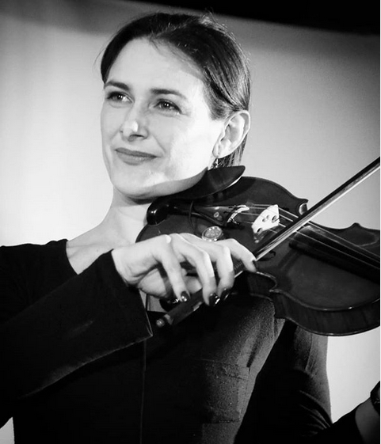
Pre-drinks: Building on the emotion created at the ceremony, this period allows guests to catch up with friends and family while taking in their surroundings. The music during this time should animate and enliven those conversations not interfere or compete with them.
Led by Rayelle Goodman, we suggest having 4 beautiful string musicians perform while guests enjoy cocktails and canapes.
Rayelle Goodman is probably Southern Africa's most versatile violinist. With 30 years' experience in violin playing, a daringly creative personality and an impressive national and international performance history, this musician brings another dimension to any collaboration.
International performance collaborations have included Josh Groban, with violinist Lucia Micarelli, folk legend Shawn Phillips, funky house band Ananda Project and classical piano virtuoso Gabriela Montero.
Rayelle Goodman was a founding member of both Freshlyground and Coda, dedicating two years to each band. Rayelle has performed in many theatre productions including Andrew Lloyd Webber's "Phantom of the Opera" (Artscape, 2004).

Reception: 15-piece classical ensemble including conductor to perform 3 x 45-minute sets during the reception featuring songs by Ennio Morricone, Vladimir Cosma and the like. This versatile ensemble can perform traditional classical pieces as well as contemporary favourites.
Here’s a selection of audio references which feature an orchestral ensemble including strings and a rhythm section – keys, bass and drums - recorded at a recent high-profile wedding we did in February:
Luther Vandross - Never Too Much
Marvin Gaye - Distant Lover
Our promotional reel included at the beginning of this proposal, also includes video footage of the orchestral ensemble and features their performance of Marvin Gaye’s I Want You as the soundtrack.
Once we’ve confirmed the repertoire, we will be better able to update you on the configuration of the ensemble.

